**Activation Function**

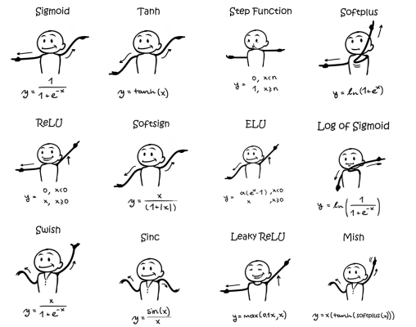

1. 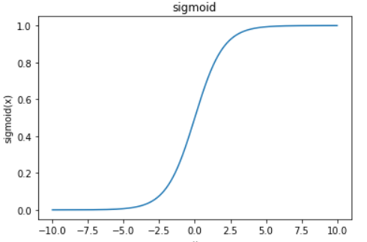**Sigmoid, tanh**

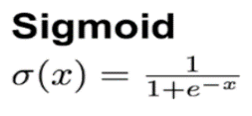

Range: (0,1)  
Linear (Exponential)  
Problem: **Vanishing Gradient**, Not Zero Centered -> **Slow Convergence (Zig-Zag)**  
Recent: Output Layer(Binary Class)

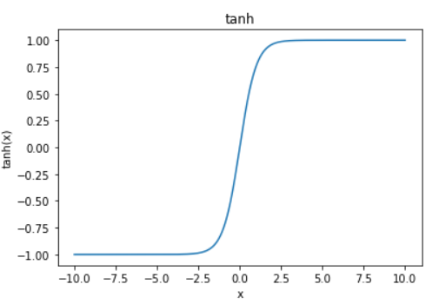

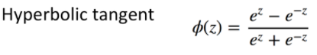

Range:(-1,1)  
Linear (Exponential), Zero Centered!  
Problem: Vanishing Gradient  
Recent: Output Layer(Binary Class), Hidden Layer(Better than Sigmoid but be careful!)

1. **Vanishing Gradient**

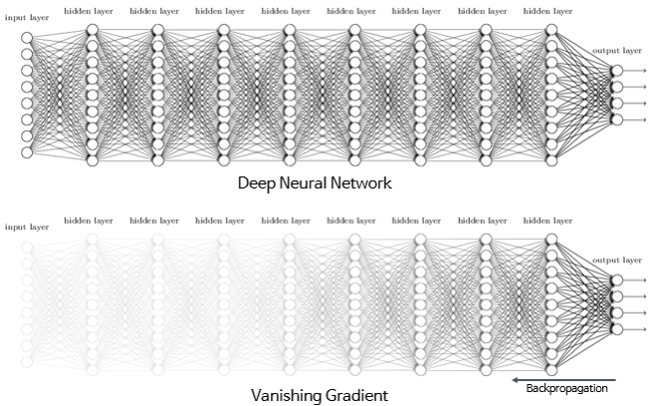

1. 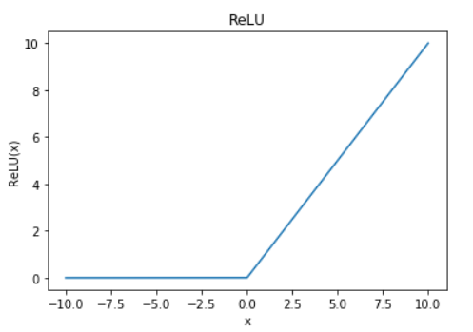Relu

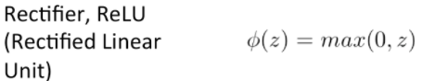

Range: [0, ∞]  
Non-Linear  
Solved Vanishing Gradient!  
Learning Speed(Easy Calculation)  
Recent: Hidden Layer(Major)

1. Limitation(Problem) of Relu

* Negative Input => 0 Output, 0 Gradient(Dying Relu)  
  ※But Sometimes, dying Relu make artificial neural network more effective(similar to drop-out)
* (Only Effective in Hidden Layer)
* **Zig-Zag**(Similar to Sigmoid)
* **Cannot differentiate at zero.**

1. **Relu Family**

* Leaky Relu(LRelu)& Parameter Relu(PRelu)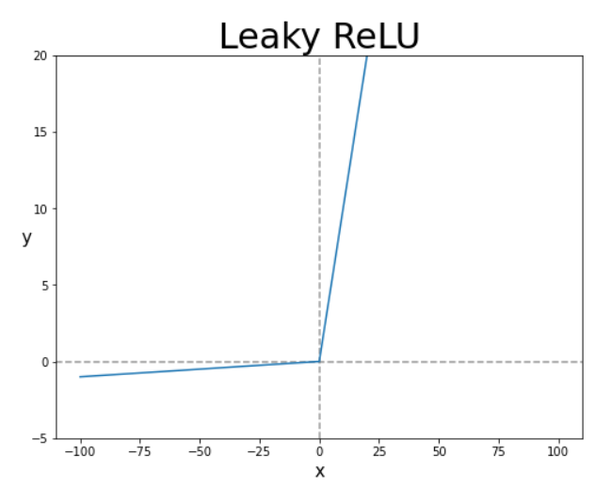

Purpose: Don’t ignore negative input!

Method: Multiply alpha(normally 0.01) on negative input

Limit: Linear on negative -> **Cannot use on complicate classification**, Poor Performance(worse than Sigmoid or Tanh)

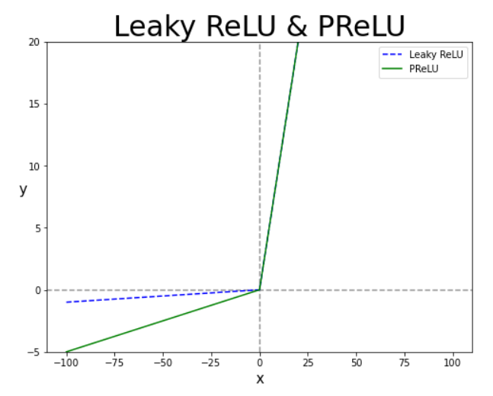

Purpose: Use alpha as weight!

Method: Update alpha by backpropagation

Limit: Same as LRelu, Overfitting Risk

* **Exponential Linear unit(ELU)**

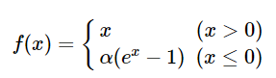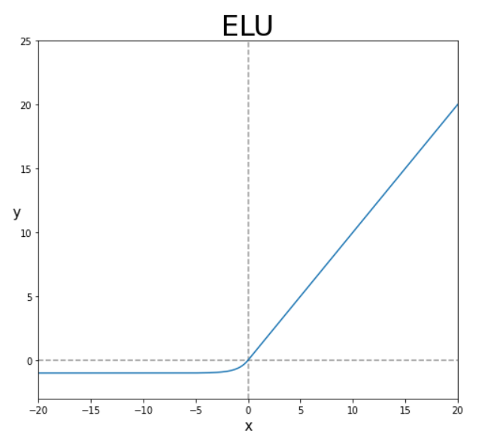

Purpose: **Make differentiable at Zero!** & **Print negative output!**

Method: Use Exponential on negative input

Limit: No significant increase on performance, low learning speed(exponential calculation)

* 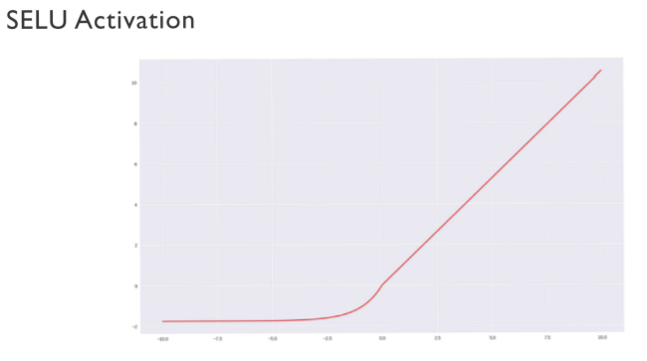**Scaled ELU(SELU)**

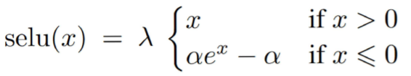

Purpose: ELU + Self-Normalizing(Similar to PRelu)

* 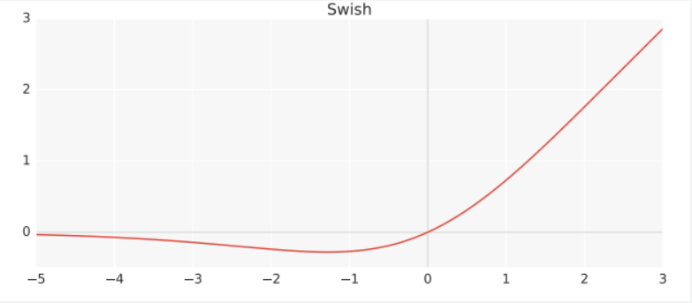**SWISH**

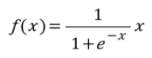

Purpose: Multiply x on sigmoid

* 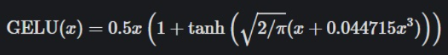**GELU**

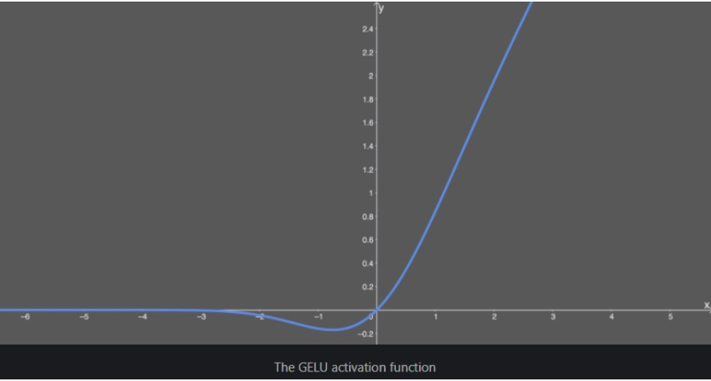Purpose:

Recent: Best above all!

그림 출처

<https://enjoyso.tistory.com/119> (Activation Function)  
<http://rasbt.github.io/mlxtend/user_guide/general_concepts/activation-functions/> (Activation Function)  
<https://excelsior-cjh.tistory.com/177> (Vanishing Gradient)

**참고 자료**

<https://gooopy.tistory.com/55> (Relu)  
<https://gooopy.tistory.com/56?category=824281> (Relu Family)  
<https://gooopy.tistory.com/52?category=824281> (Sigmoid)  
<https://gooopy.tistory.com/54?category=824281> (Hyperbolic Tangent)  
<https://brunch.co.kr/@kdh7575070/27> (Dying Relu)  
<https://medium.com/@neuralnets/swish-activation-function-by-google-53e1ea86f820> (SWISH)